**4 Description of the Model**

**4.1 EV Agent Model**

Our study adopts EV agent model that was introduced by *López et al.* in 2011.[6] EV agent is a conceptual demand management agent that is responsible for finding optimal charging solutions based on collected information about participating EVs. Figure P schematically illustrates the communication between EV agent and EVs. When an EV arrives home, instead of charging immediately, it sends information about its current state of charge(SOC) and next scheduled departure time. The EV agent processes such information from all participating EVs and sends back to each vehicle a charging plan, which contains information about when and how the vehicle should charge.

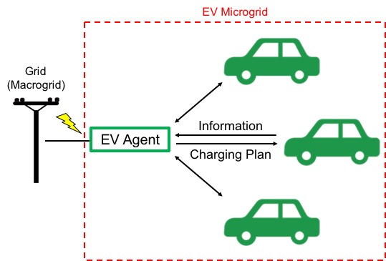

Figure P: Schematic diagram of EV agent model

Our model is based on a number of simplifying assumptions:

* All vehicles are the same model and thus have the same technical specifications—for example, battery capacity, fuel economy, and plug-in charging rate. In our study, all vehicles are assumed to be Tesla Model S (2015 85D Option).
* Vehicles only charge at home. Although some vehicles use charging stations in reality, the majority of EVs still charge at home, making this assumption a reasonable abstraction. This assumption leads to the two following assumptions.
* EVs whose traveling distance between their departure from home and return exceeds the driving range of Tesla Model S (approximately 250 miles) are excluded from our analysis because excessively long journeys lead to a negative SOC value.
* Vehicles that do not return home are also excluded from our analysis.
* All vehicles charge with 240V charging cable. (Charging rate: approximately 9.6 KW)[7]
* Since our model analyzes vehicles in one grid system, we choose to examine vehicles in one region, Texas.
* Electricity pricing follows the actual residential electricity prices in El Paso, Texas. The peak hour price, which occurs from 12:00 to 20:00 daily, is 0.15831 USD/KWh; the off-peak price is 0.06743 USD/KWh.[8]
* The driving profiles of vehicles are the same everyday.

In order to understand EVs’ influence on grid robustness, we should first find EVs’ total power consumption from the grid over time. Total power consumption is the sum of individual power consumption. A charging EV—SOC of which is increasing—draws 9.6 KW of power from the grid. Therefore, individual power consumption at time *t* can be defined by a simple piecewise function:

$$\left(individual power consumption\right)=\left\{\begin{aligned}9.6 KW (charging) \\ 0 (not charging)\end{aligned}\right.$$

And total power consumption at *t* is defined as follows:

$$\left(total power consumption\right)= \sum{\left(indiviual power consumption\right)}$$

$$=9.6 KW × (number of charging vehicles)$$

Next, to examine how much cost can be saved by our microgrid, daily total cost should also be calculated.

$$\left(daily individual cost\right)= 9.6 KW × \left(on-peak charging hours\right) × \left(on-peak price\right)$$

$$+ 9.6 KW × \left(off-peak charging hours\right) × \left(off-peak price\right)$$

$$\left(daily total cost\right)= \sum{(daily individual cost)}$$

**4.2 Alternative Charging Plans**

As soon as an EV is parked at home, it informs the EV agent how much time it needs to be fully charged and when its next departure is. EV agent makes one of the two following decisions:

1. (time until next departure) – 60 minutes $≤$ (time required for charging)

: charge the EV immediately (original charging plan)

1. (time until next departure) – 60 minutes $>$ (time required for charging)

: sends back an alternative charging plan

Figure X shows the SOC curves with an original charging plan and five alternative charging plans. Alternative plans distribute power consumption by delaying charging or dividing charging into two or three steps. Before and after each charging step, there are pauses of random lengths (marked with “R” in Figure X), which play a key role in randomly distributing power consumption.

Here, a very simple SOC curve is presented as an example. This sample vehicle is used and thus discharges from 5:00 to 10:00; it starts charging at 10:00 (*thome*); its next scheduled departure is at 20:00 (*tleave*). The curves in Figure X confirm that SOC between *thome* and *tleave* changes differently as different alternative charging plans are applied. Table A characterizes all charging plans. In Alternative Plans 2 and 4, the first charging step starts immediately; however, the second and third steps are placed randomly.

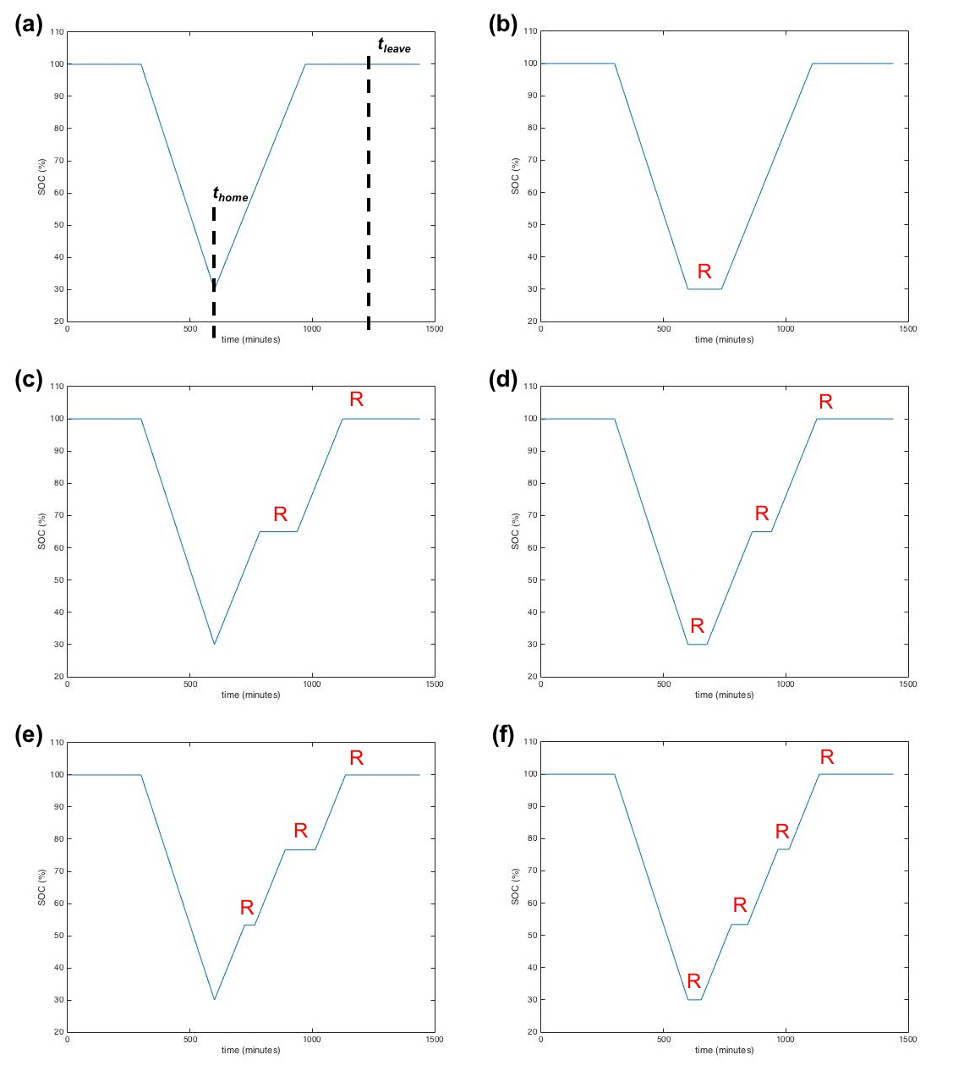

Figure X: SOC curves with different charging plans

(a) original charging plan, (b)-(f) alternative charging plans 1 through 5

|  |  |  |  |
| --- | --- | --- | --- |
|  | Start | Number of Steps | Figure |
| Original Plan | Immediate | 1 | X(a) |
| Alternative Plan 1 | Random | 1 | X(b) |
| Alternative Plan 2 | Immediate | 2 | X(c) |
| Alternative Plan 3 | Random | 2 | X(d) |
| Alternative Plan 4 | Immediate | 3 | X(e) |
| Alternative Plan 5 | Random | 3 | X(f) |

Table A: Charging plans

(Check if the definition of “scheme” is introduced elsewhere)

[6] M. A. López et al., Optimal Microgrid Operation with Electric Vehicles, 2011 2nd IEEE PES International Conference and Exhibition on Innovative Smart Grid Technologies (ISGT Europe), 2011.

[7] teslamotors.com/models

[8] price source